**ToDo List App UI Output**

Welcome screen:

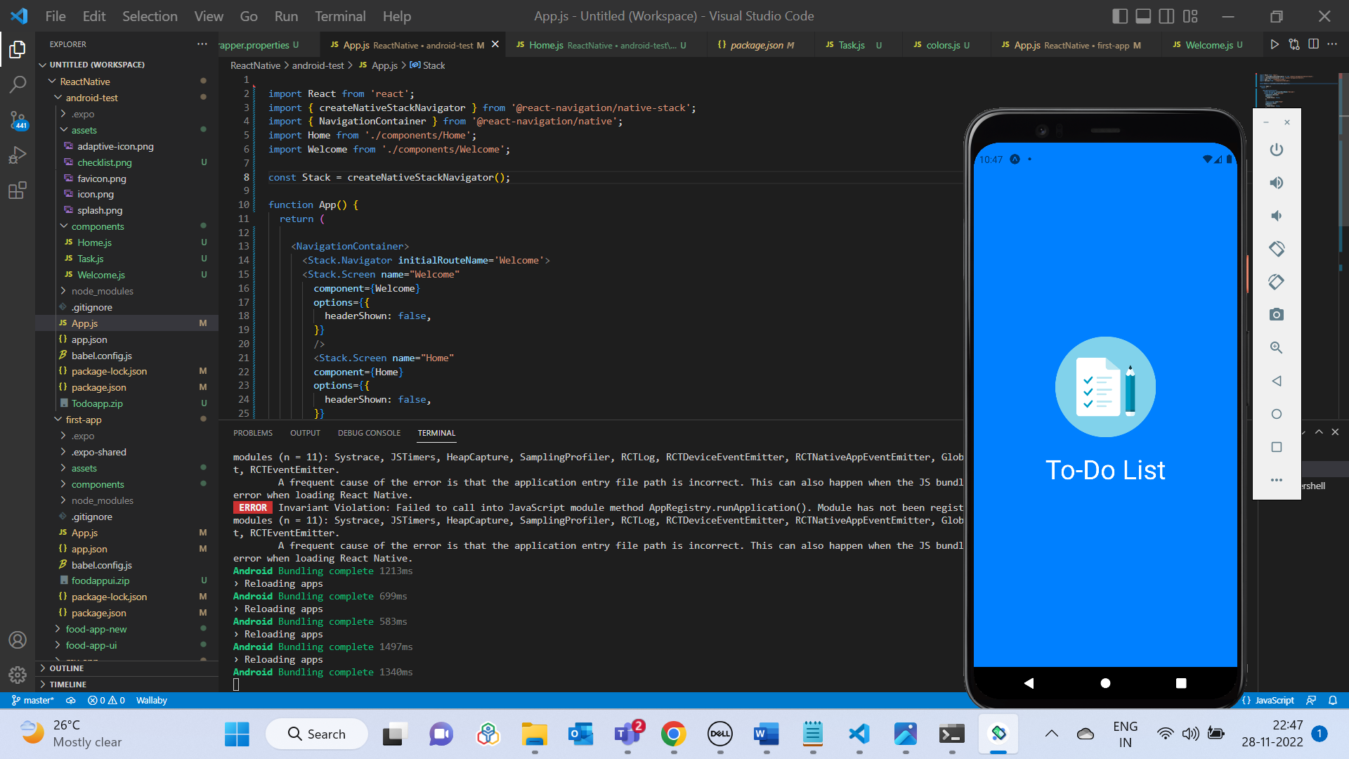

After 5 seconds navigates from Welcome page to Home screen:

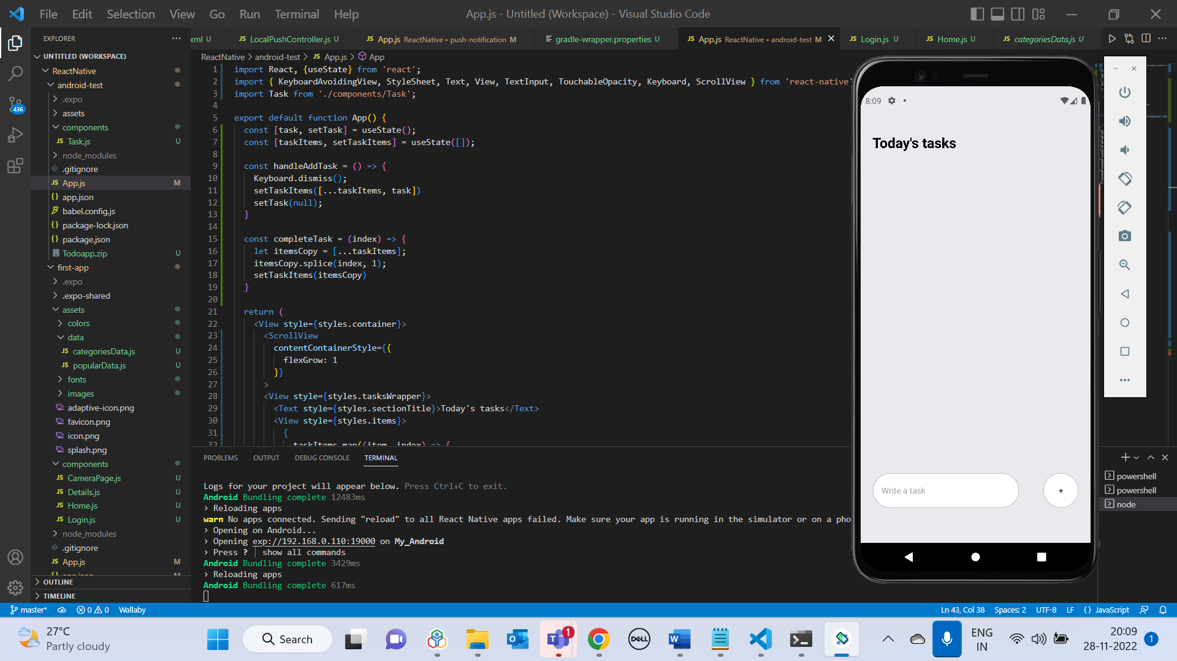

Adding a Task:

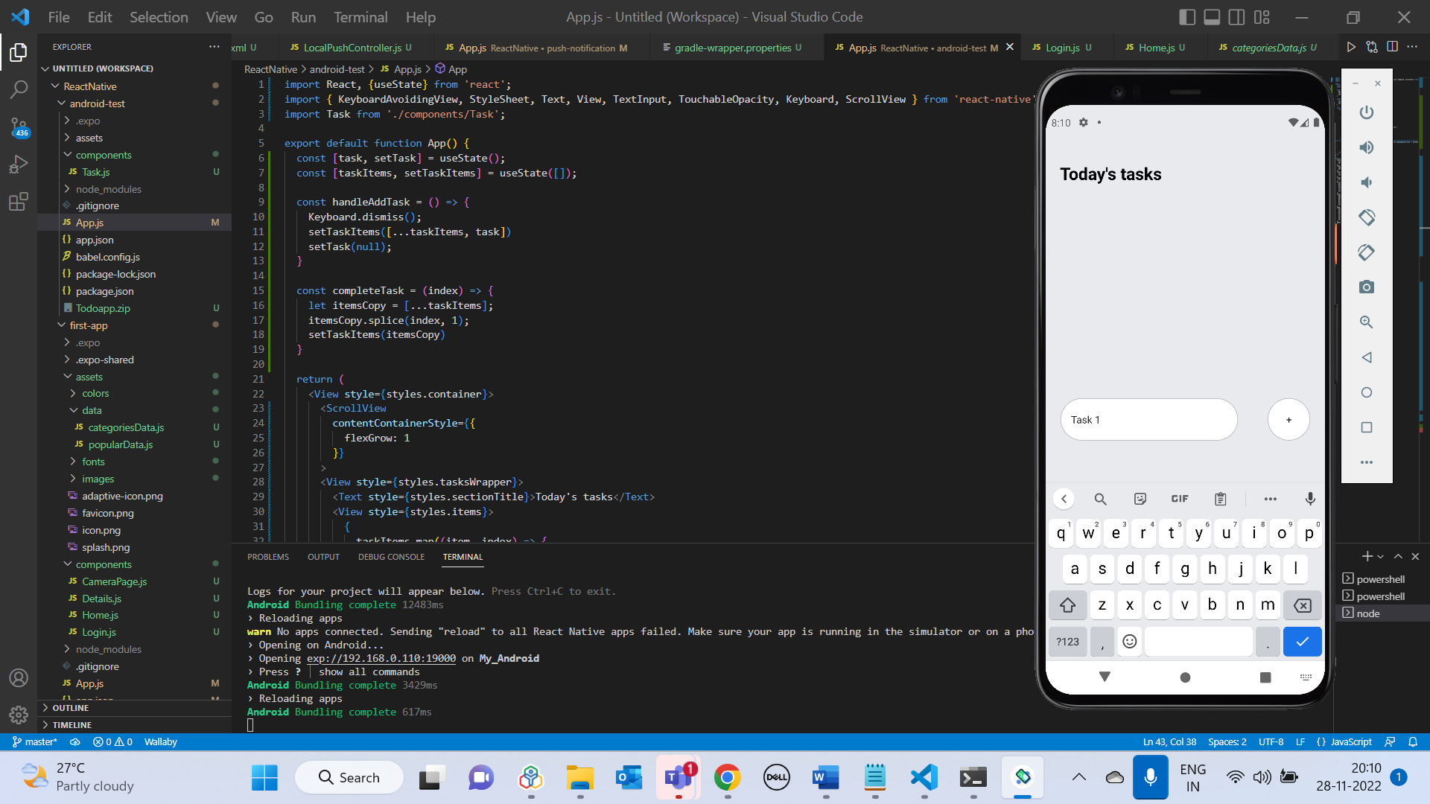

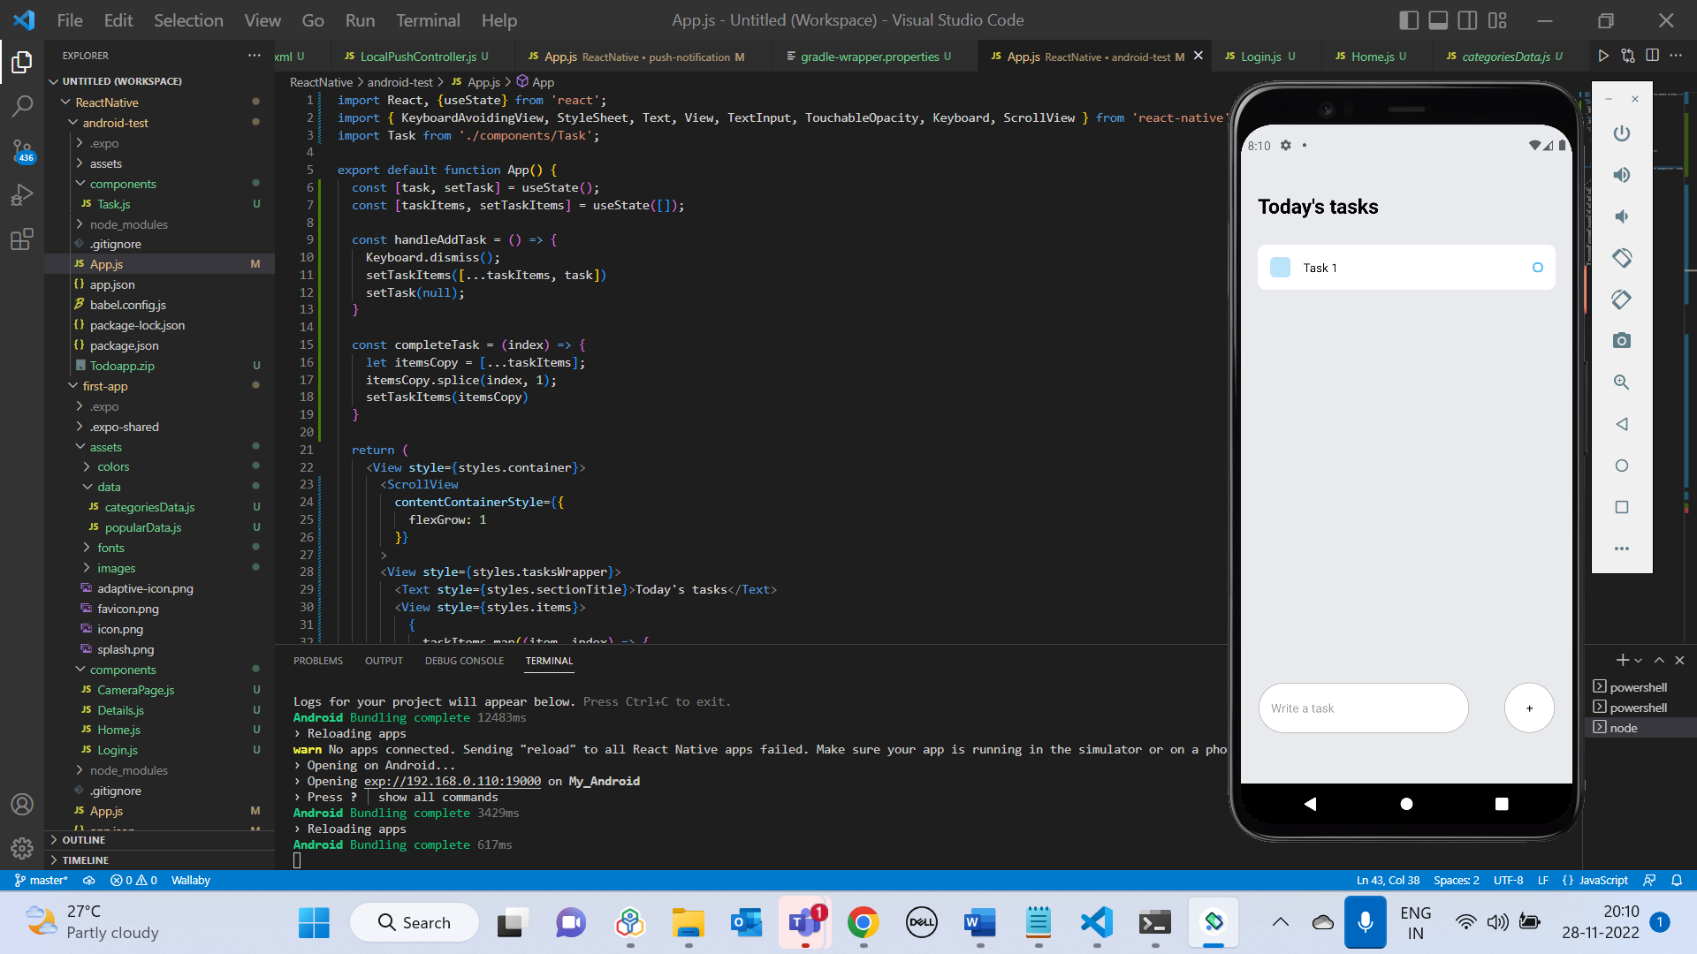

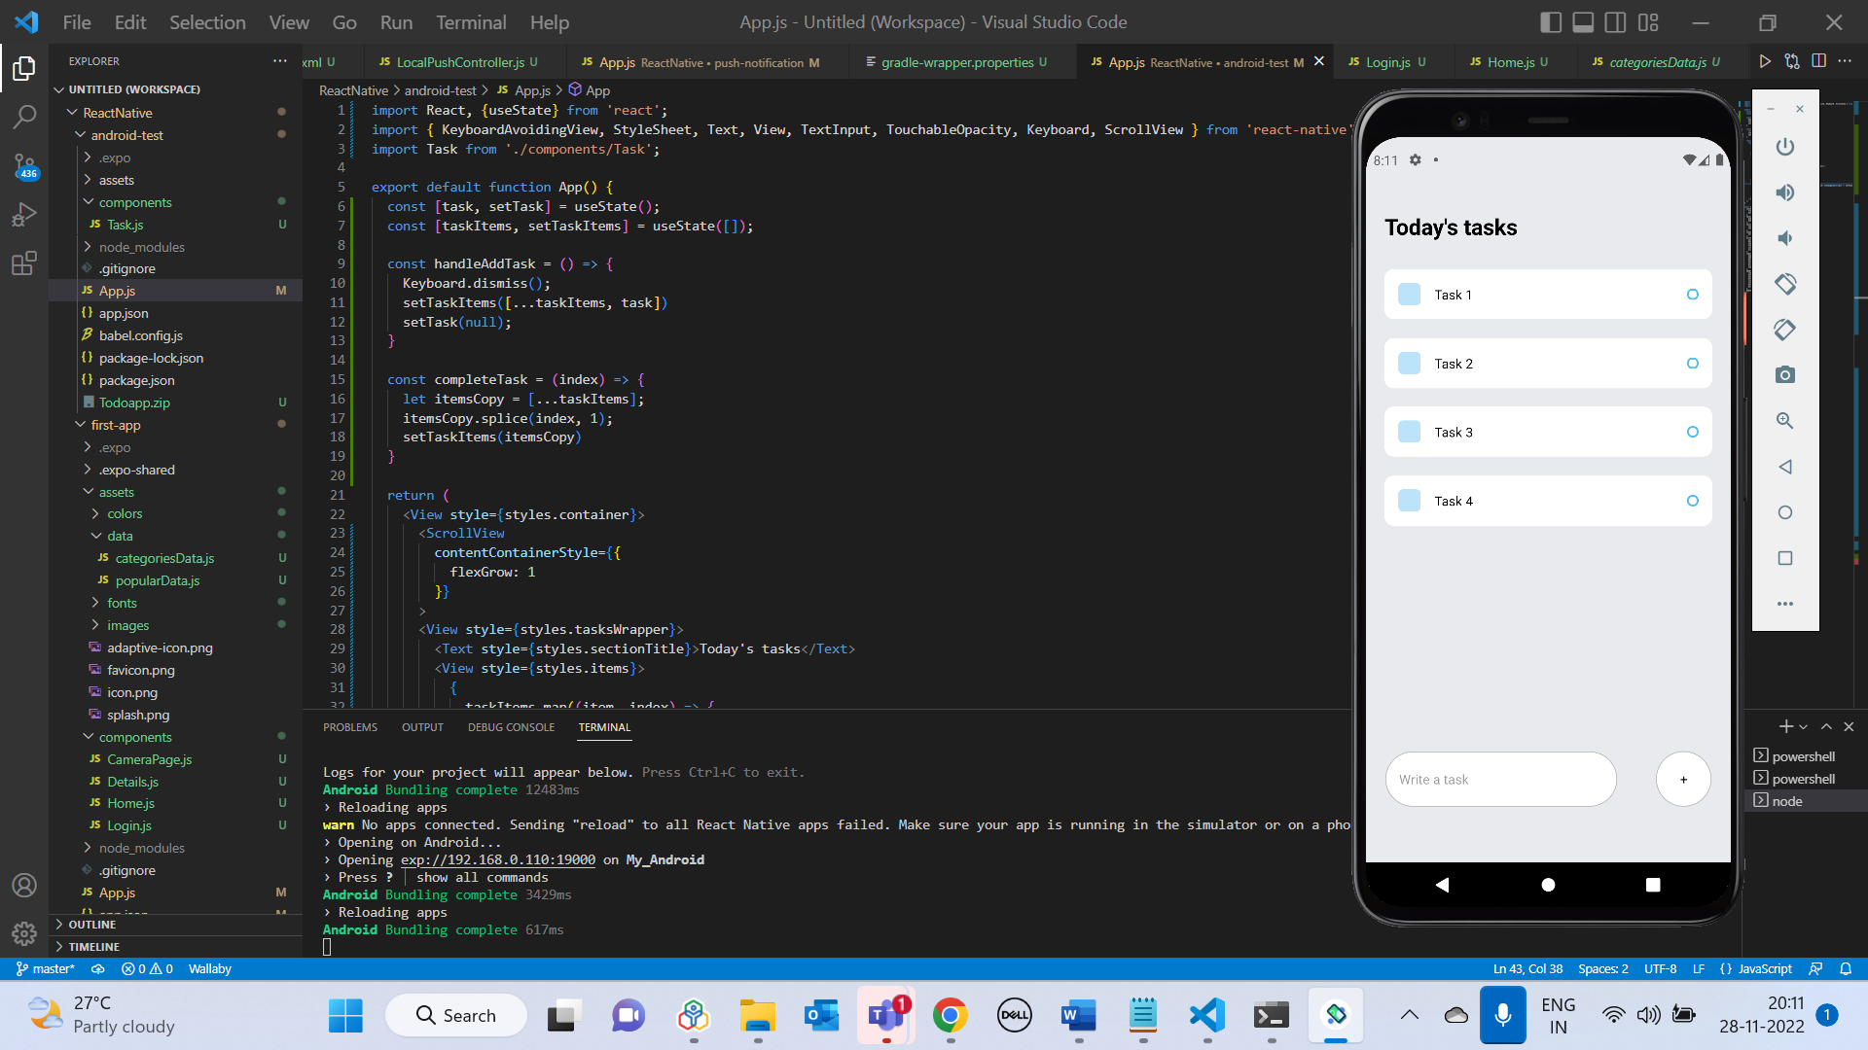

Clicking on the Task deletes the particular task – Task 2 deleted:

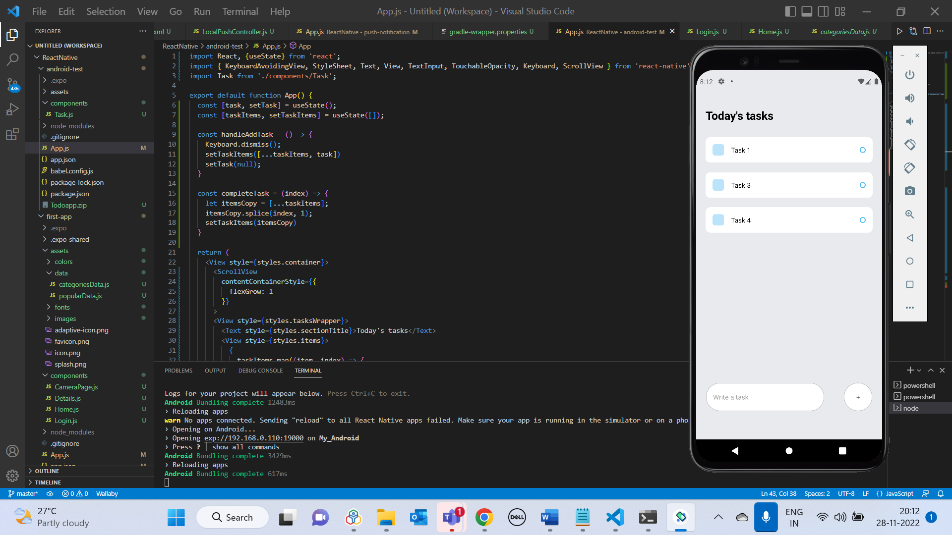

**Sample Food App UI output**

Login screen:

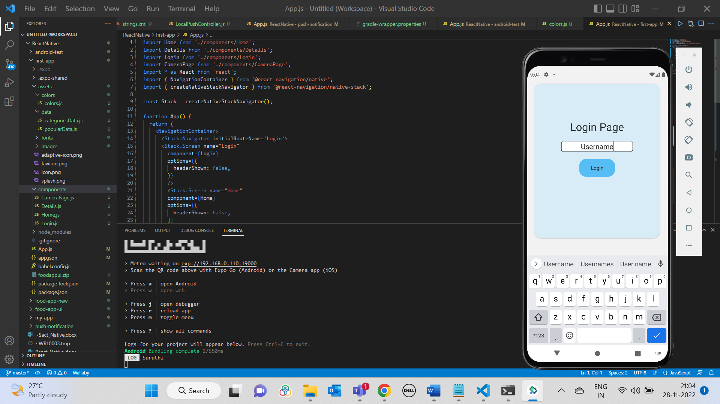

Home Screen:

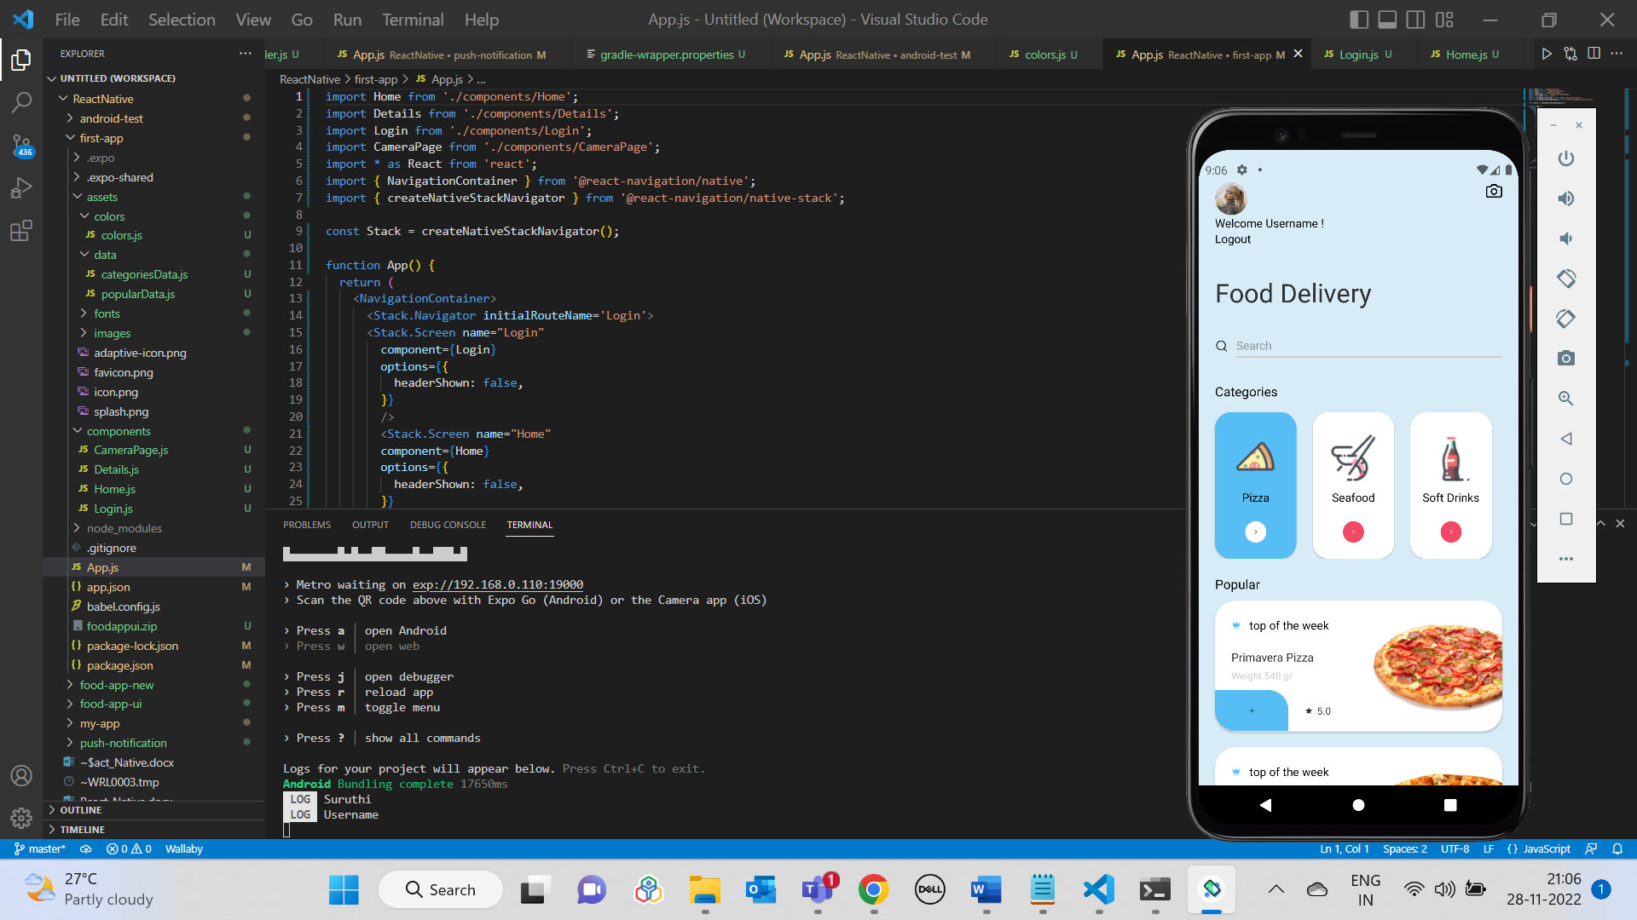

Clicking on an item in Popular list (Logs item details and navigates to Item’s details page):

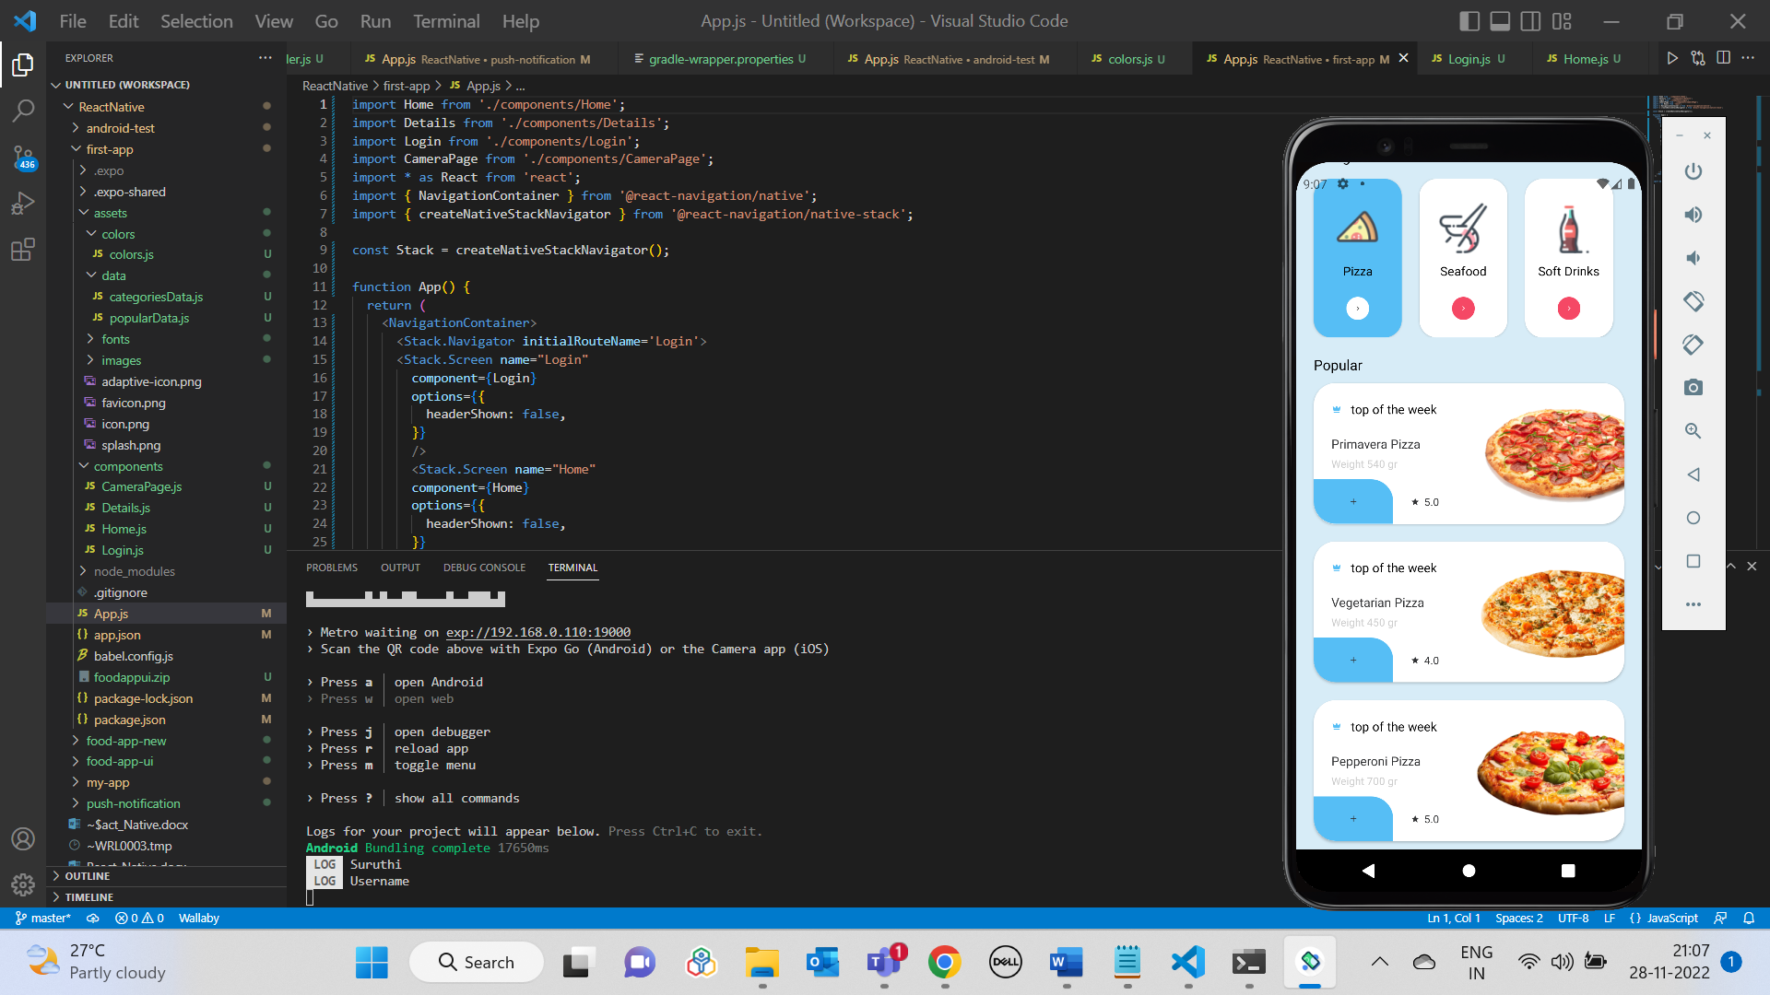

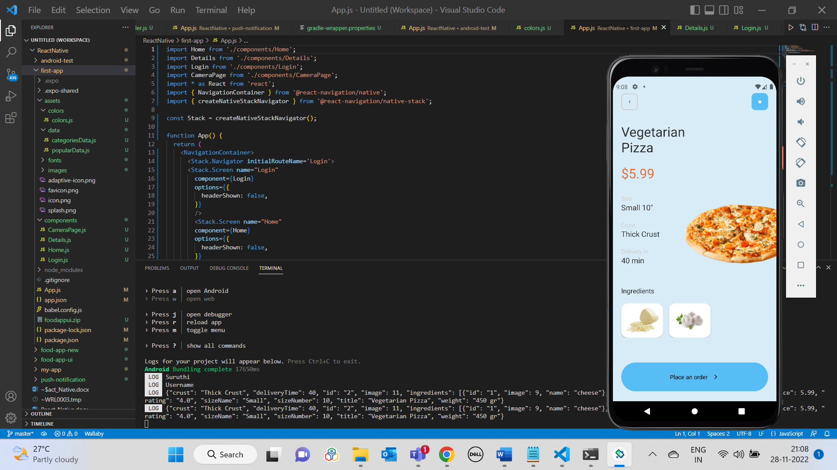

Clicking on Place an Order button:

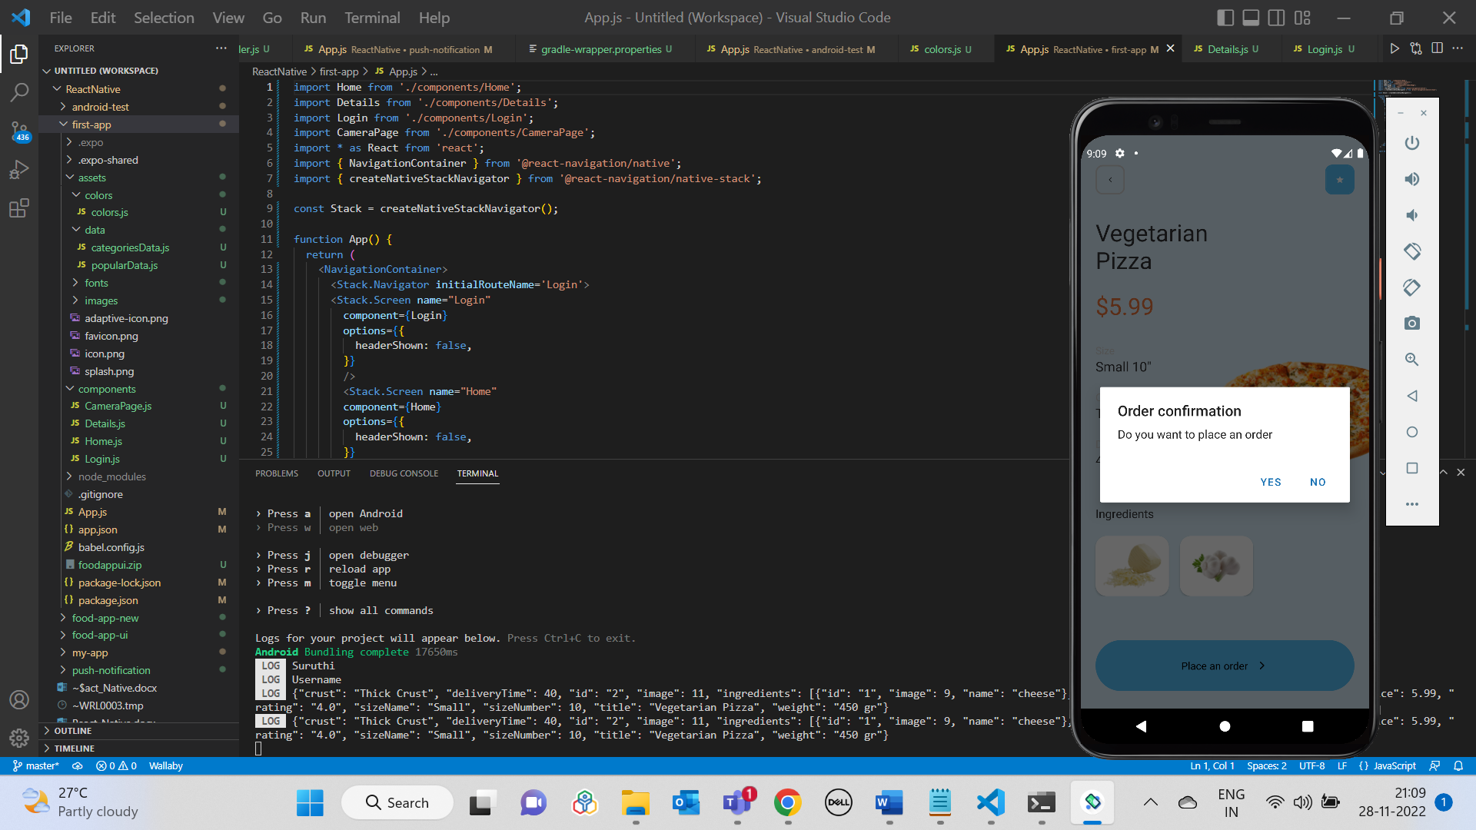

Clicking on Yes (Logs “Order placed”):

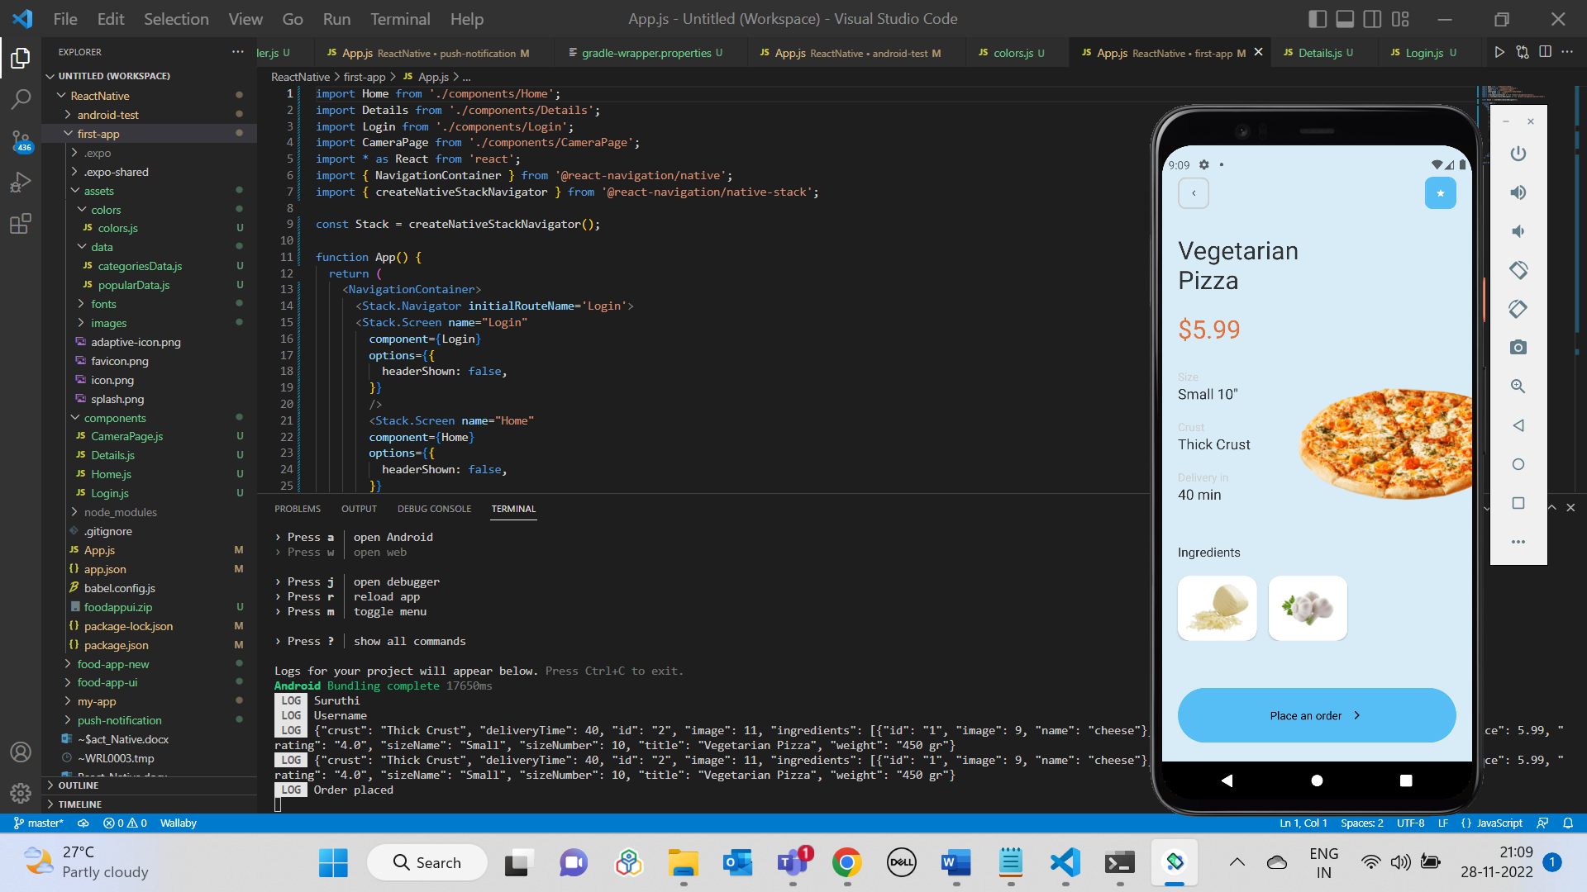

Camera button in Home screen:

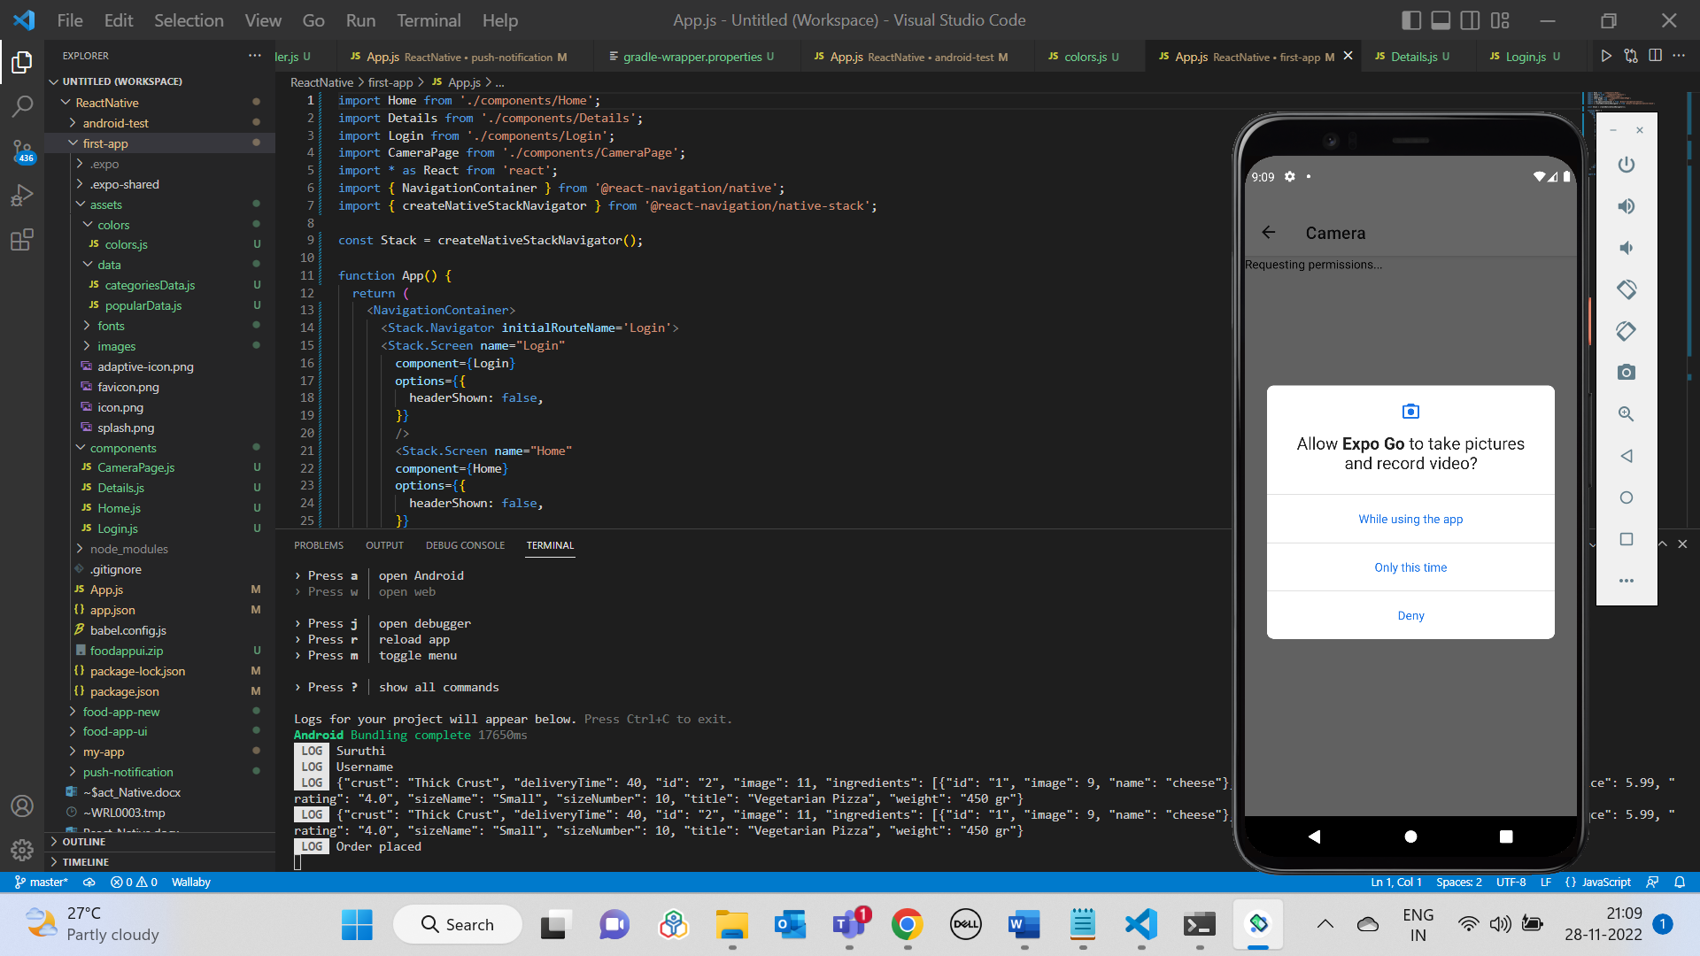

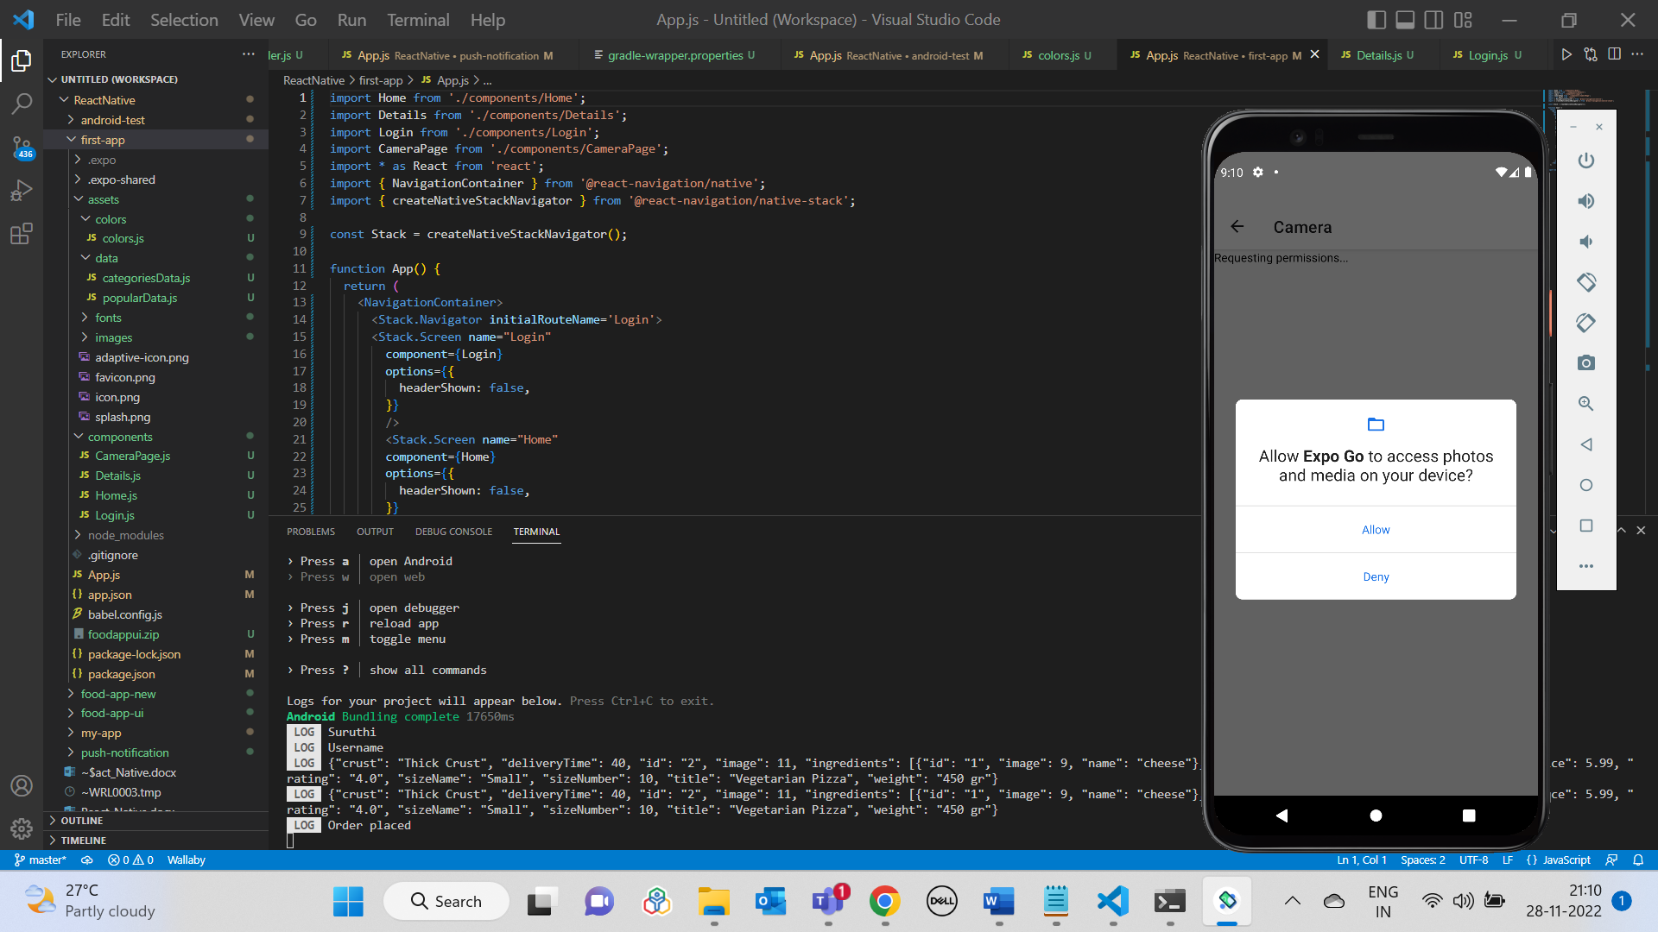

Clicking on Take Picture button:

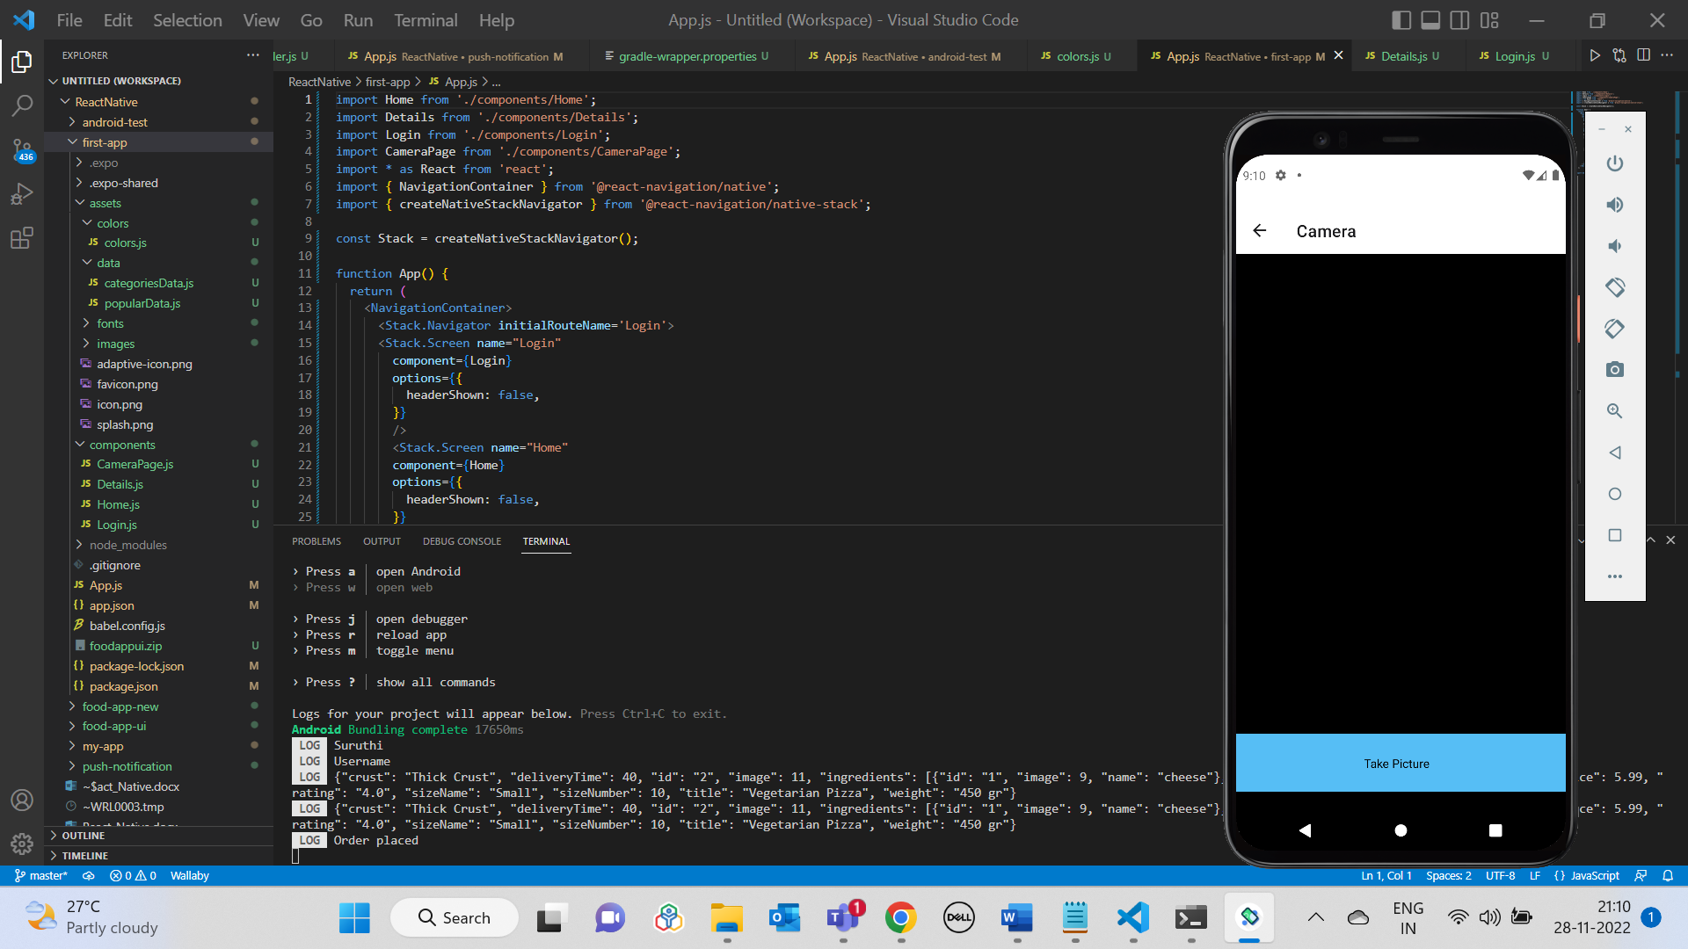

Preview page:

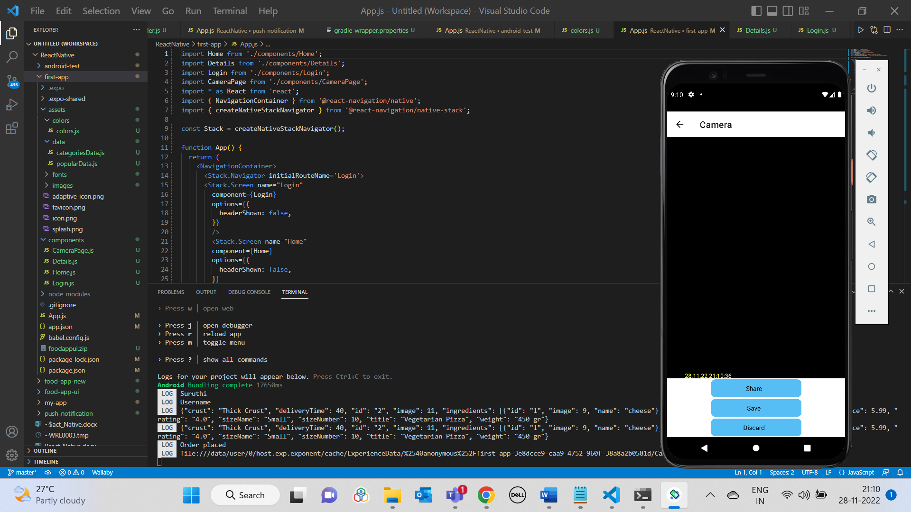

Clicking on Save button in Preview page:

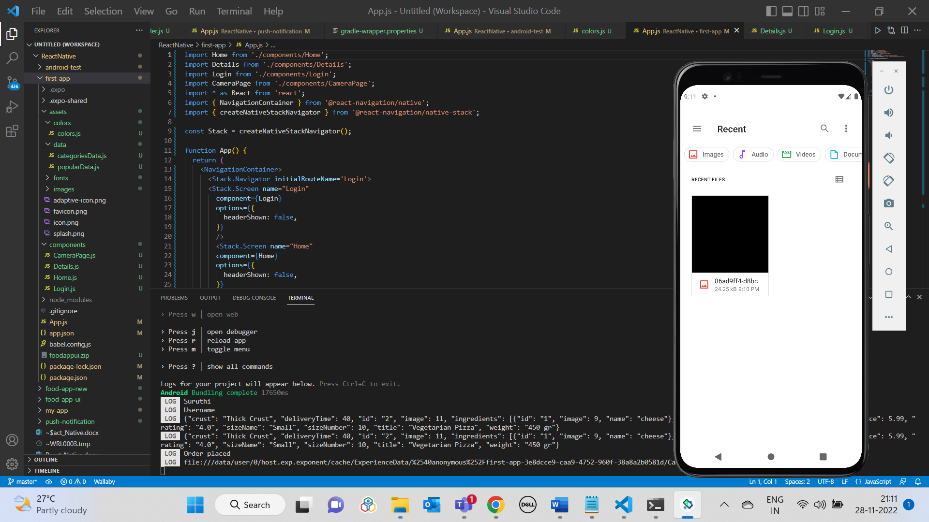

Clicking on Share button:

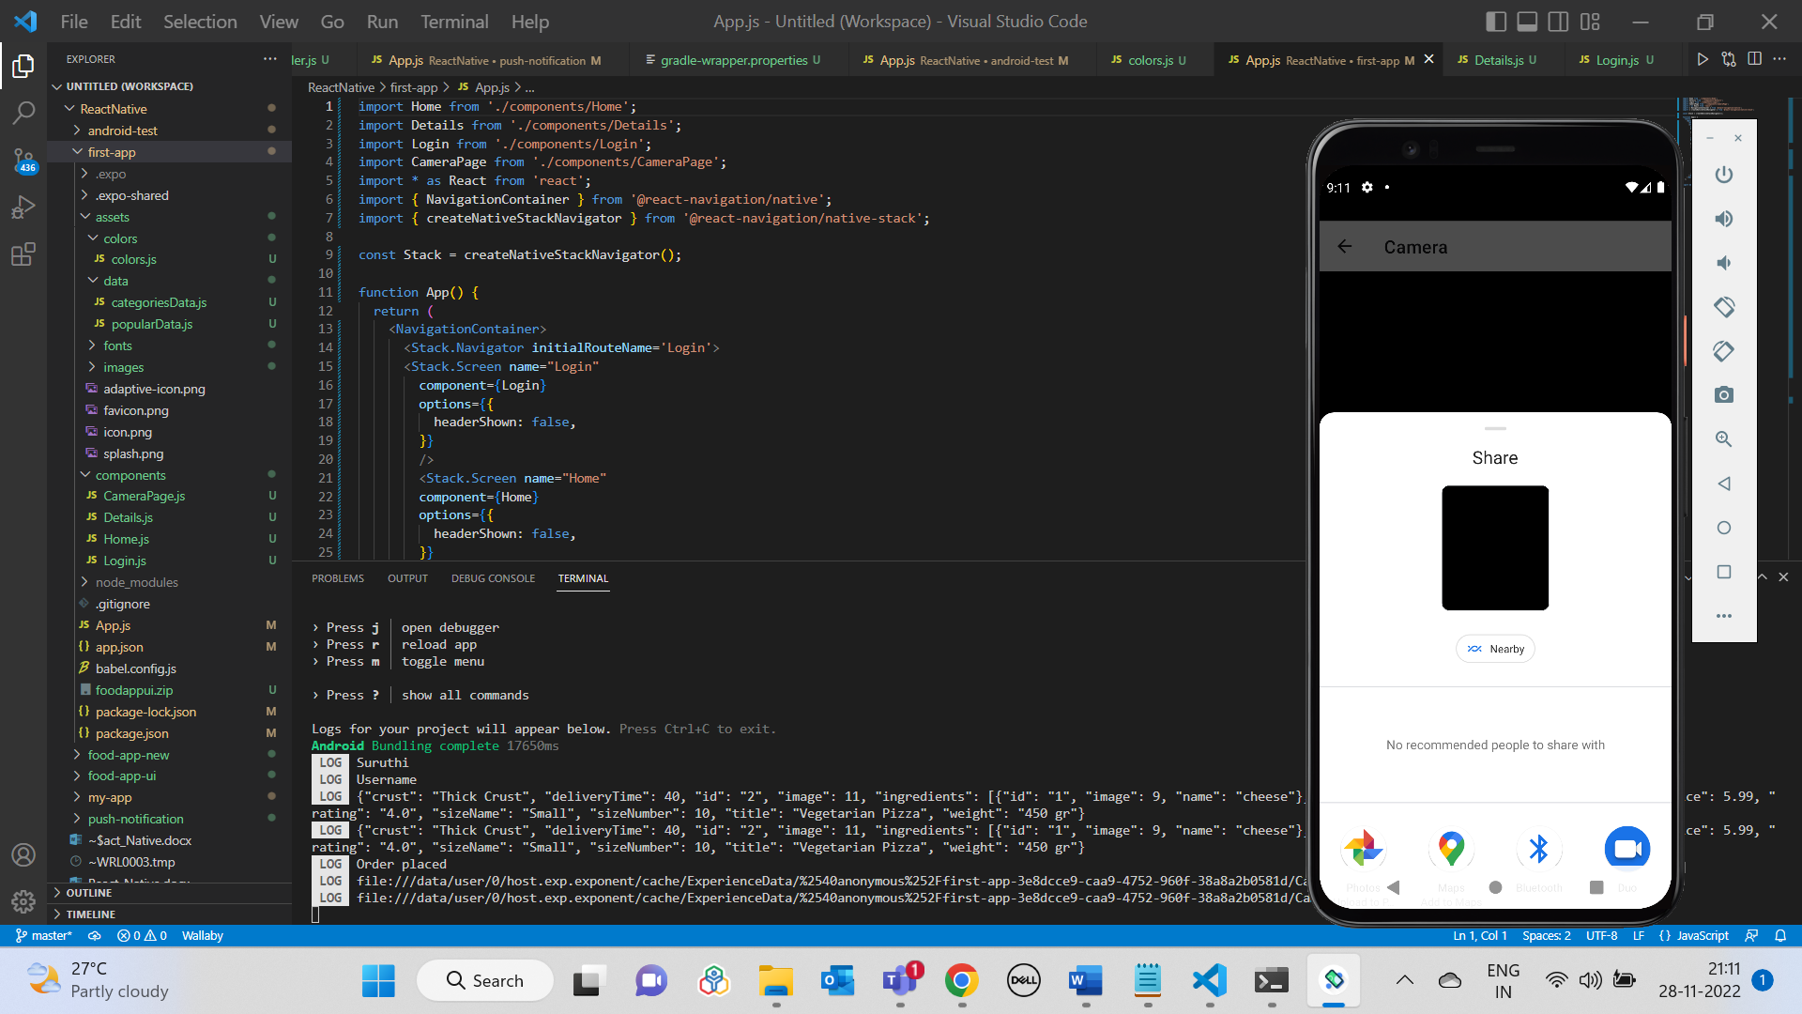

Clicking on Discard button:

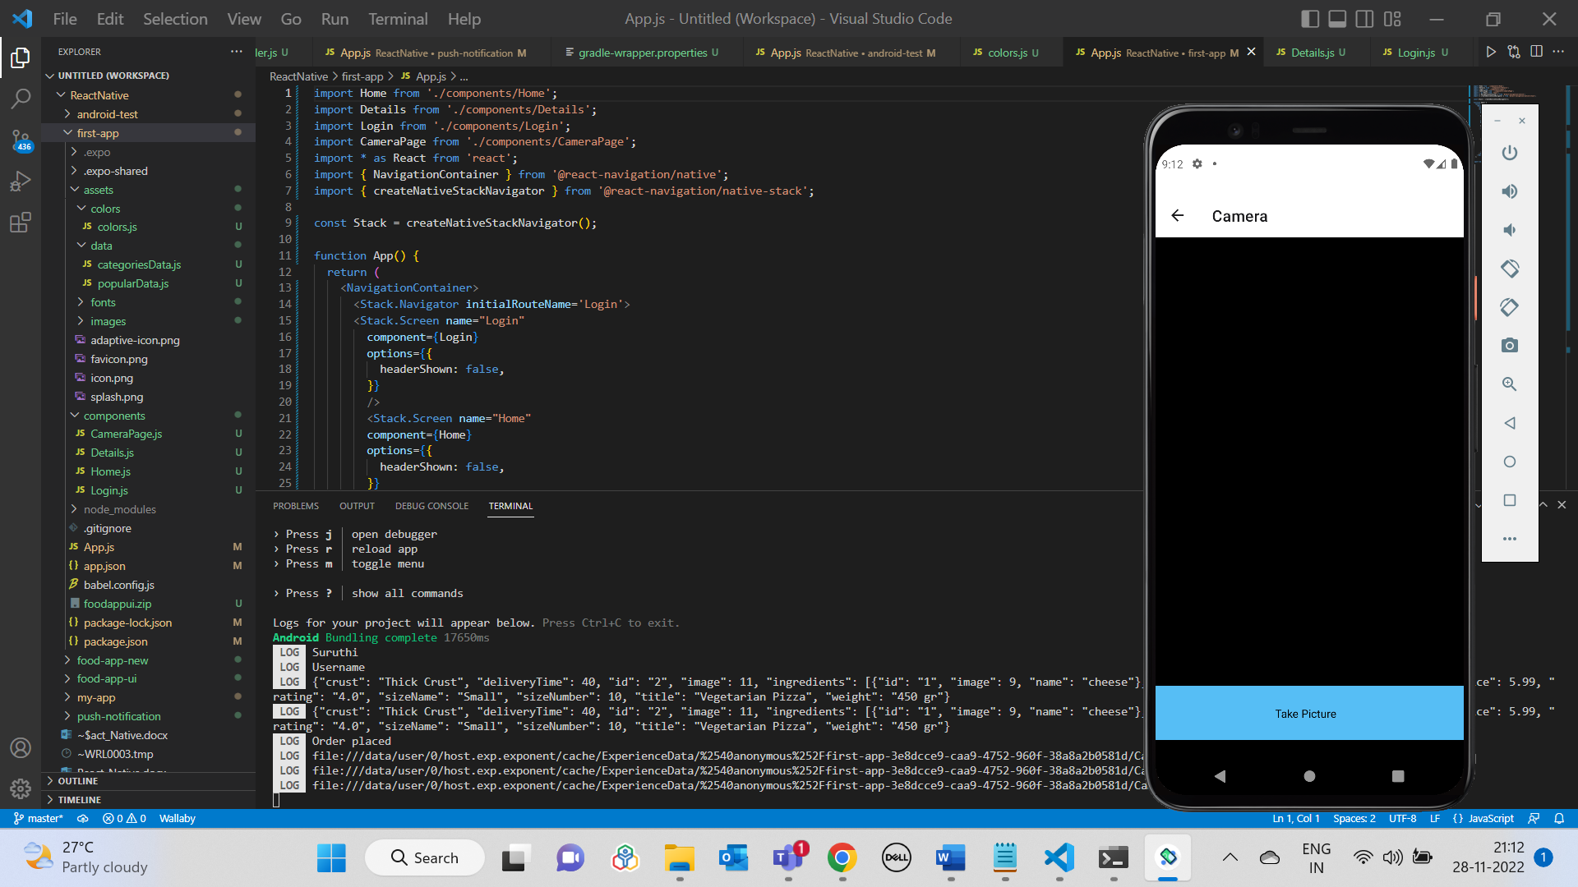

**Quiz App UI Output**

|  |  |
| --- | --- |
|  |  |

|  |  |
| --- | --- |
|  |  |

**Twitter Reference App UI Output**

**Create your account screen:**

Next button will be disabled if any of the fields are empty.

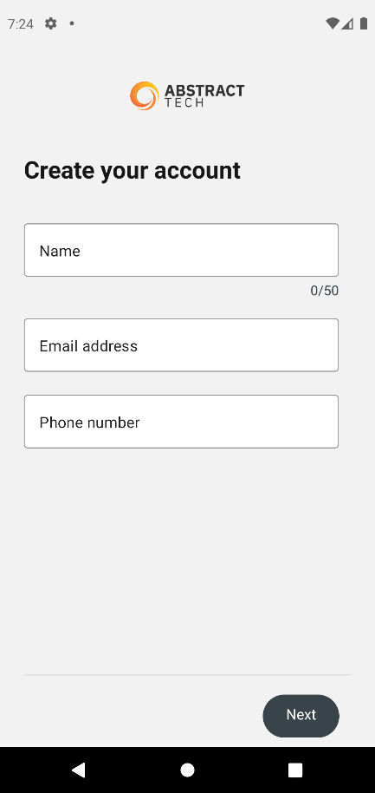

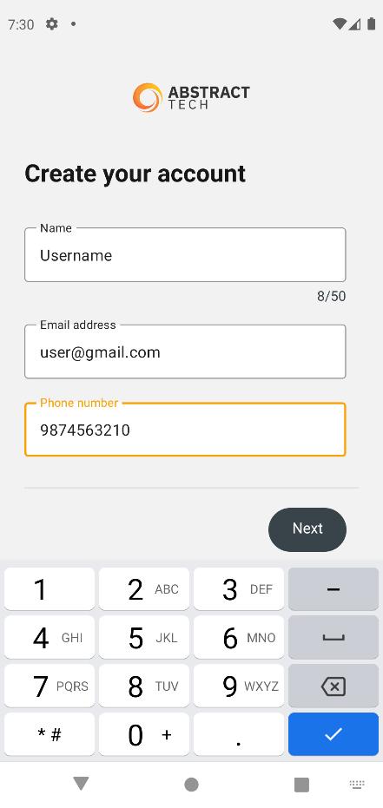

**Privacy policy screen:**

Next button will be disabled if the statement is unchecked.

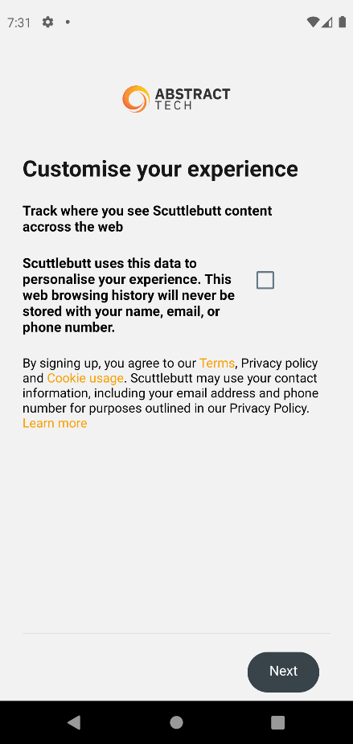

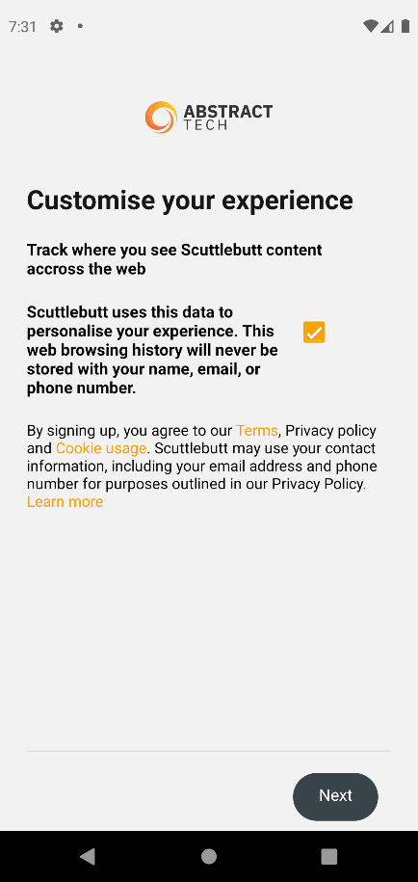

**Sign Up screen:**

Displays details provided in Create your account screen for confirmation.

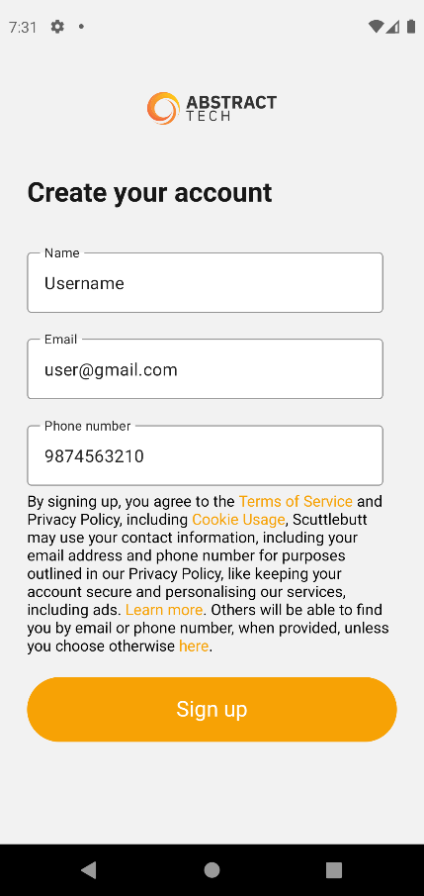

**Verify phone number screen:**

Displays phone# provided in Create your account screen for verification.

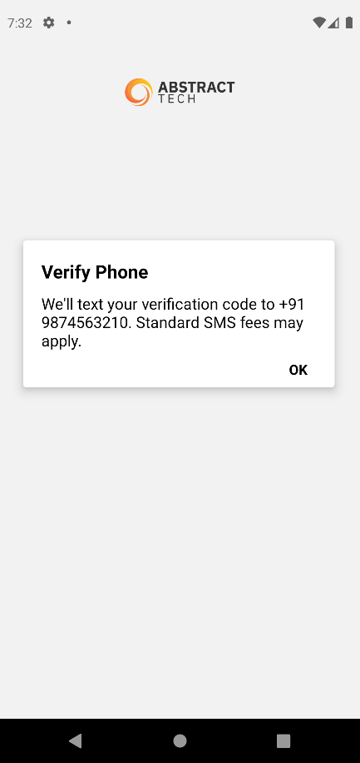

**Code verification screen:**

UI containing input field that accepts only 6 numeric characters.

Next button will be disabled if the condition is not satisfied.

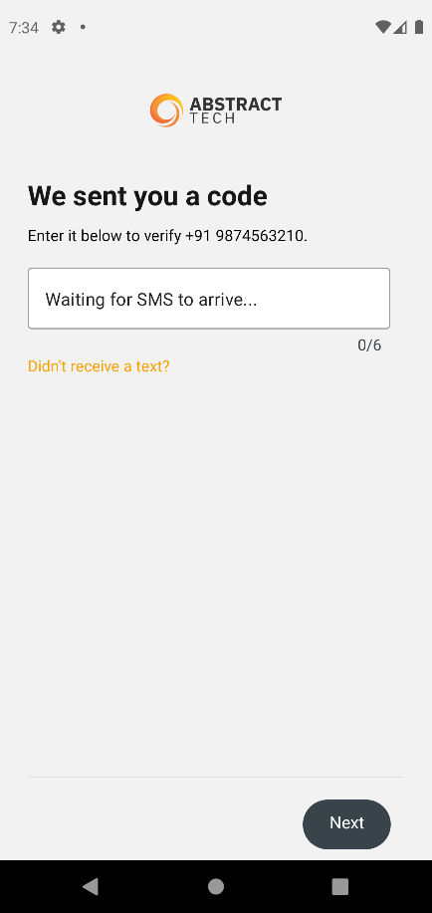

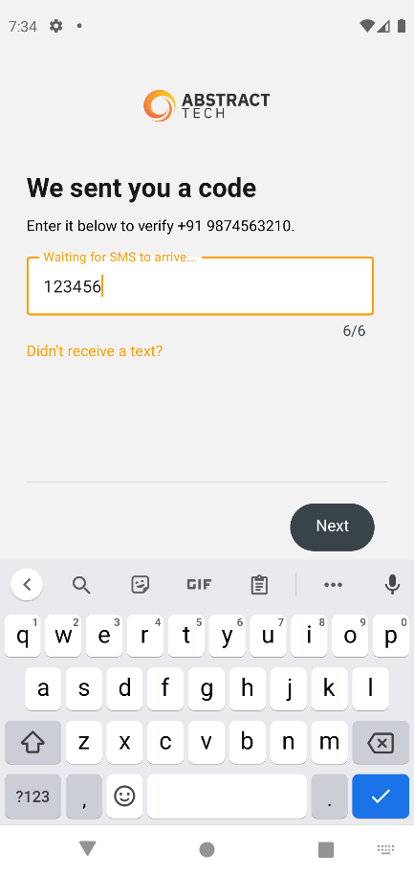

**Provide password screen:**

Accepts any password with more than 8 characters.

Next button will be disabled if the condition is not satisfied.

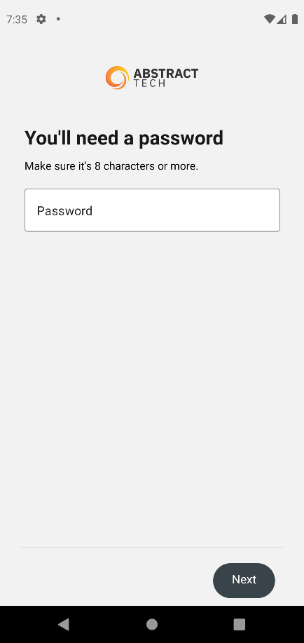

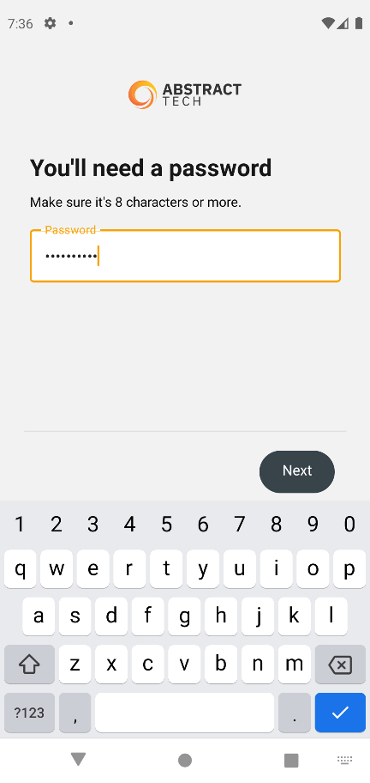

**Upload Profile picture screen:**

Clicking on “Upload” will lead to Gallery.

Next button will be disabled if picture is not uploaded. Profile picture will be displayed in the Dashboard screen.

Skip for now will navigate to the next screen without uploading the picture.

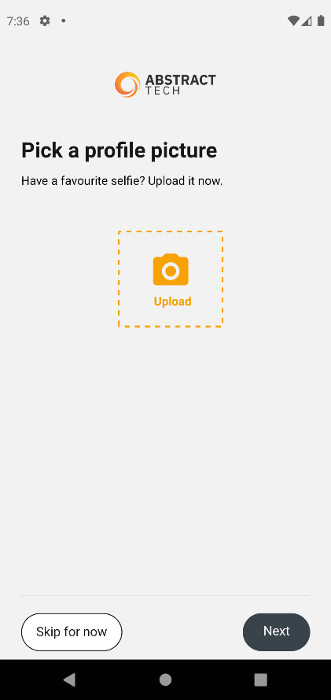

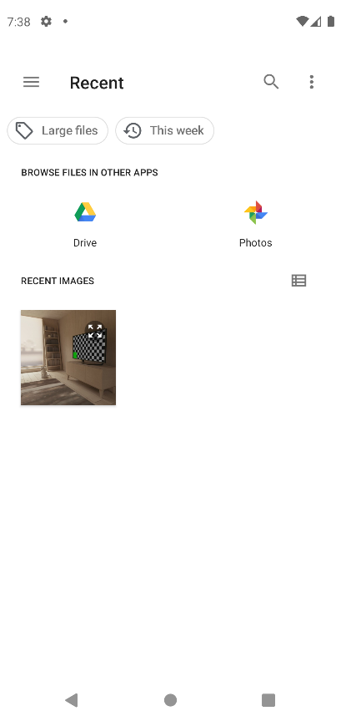

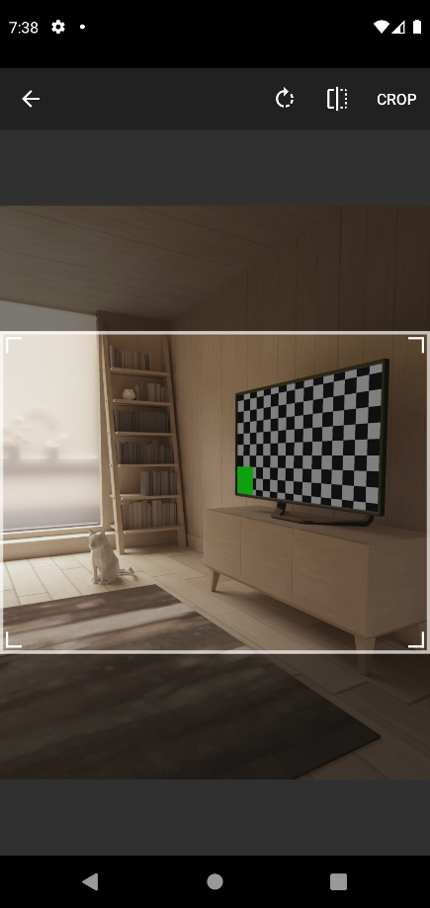

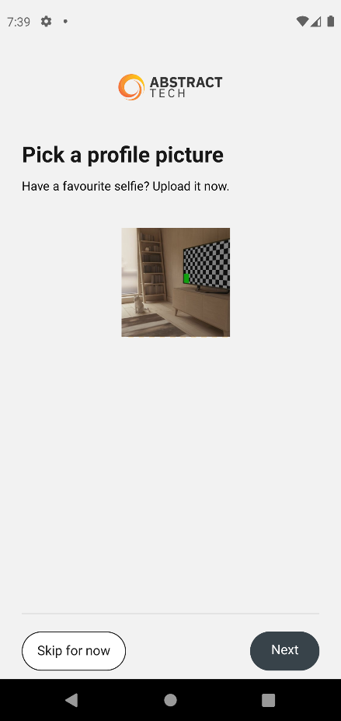

**Provide Username screen:**

Next button will be disabled if username is not provided.

Skip for now will navigate to the next screen without providing username.

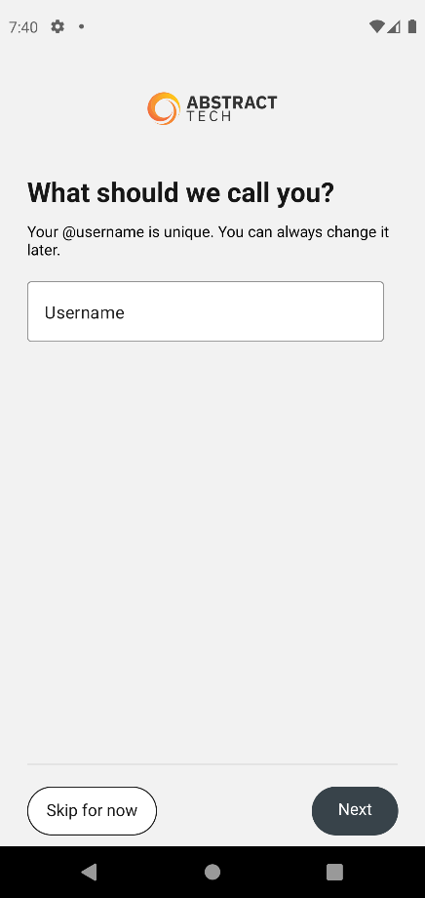

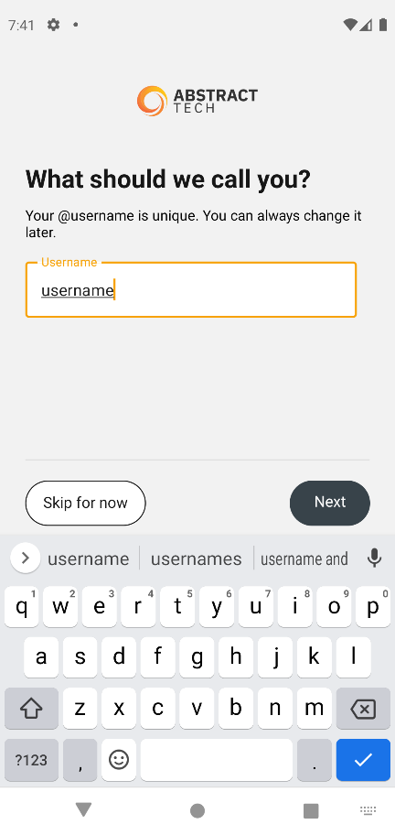

**Dashboard screen:**

Tab 1: Home Tab ( Data fetched from Fake API. URL - <https://mocki.io/v1/f6ed5188-5b36-4c69-b80a-ec01164a227b> )

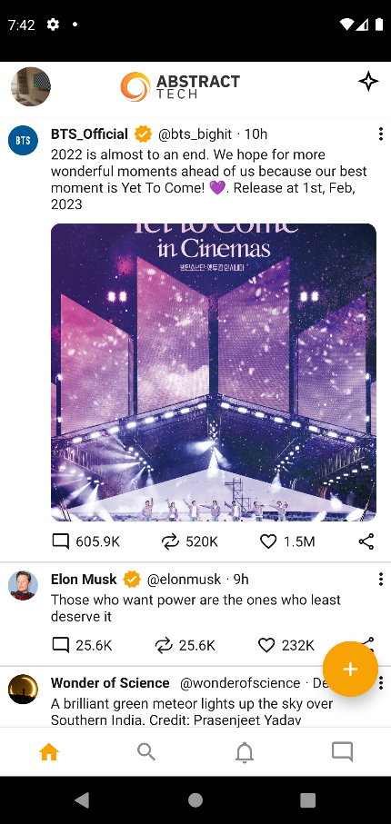

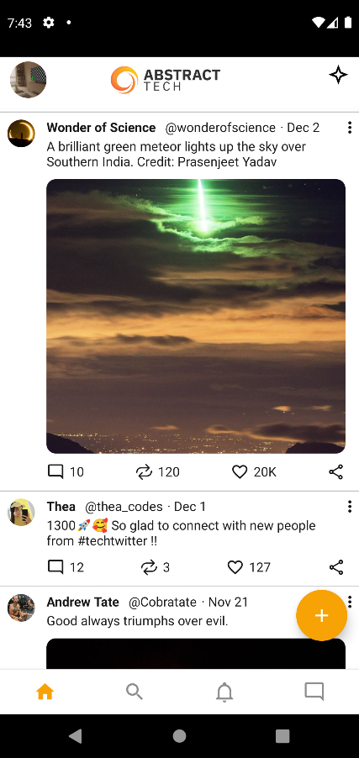

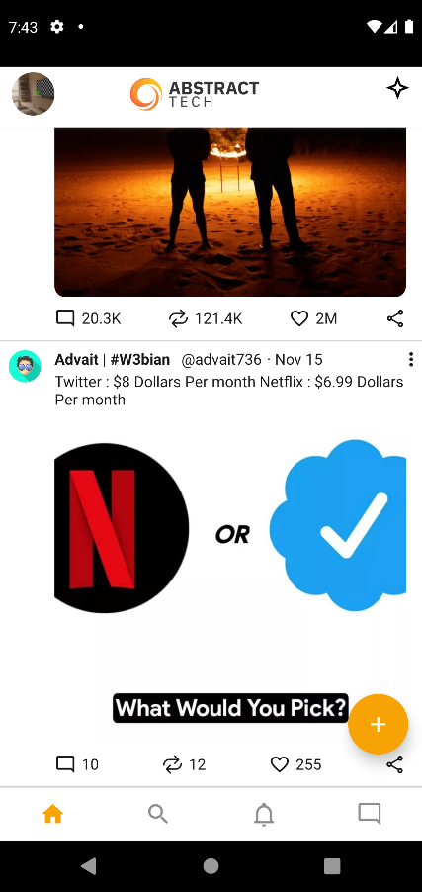

Clicking on a username will navigate to particular user profile screen.

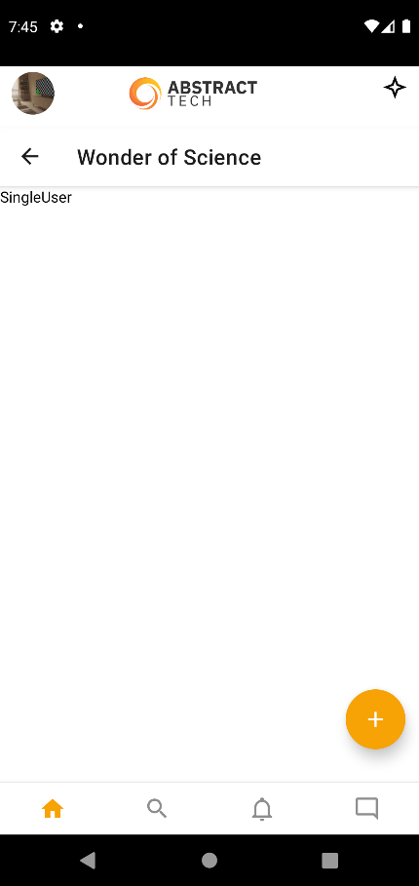

Tab 2: Search Tab

If found, provides the user name that is been searched.

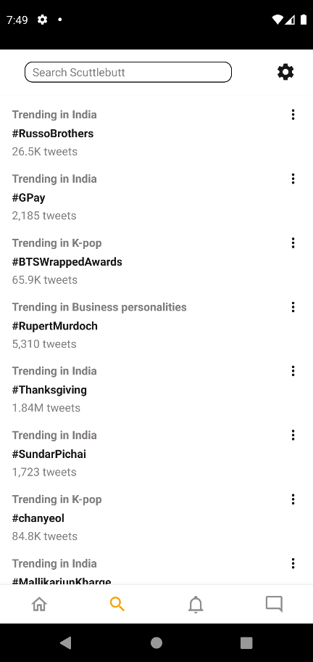

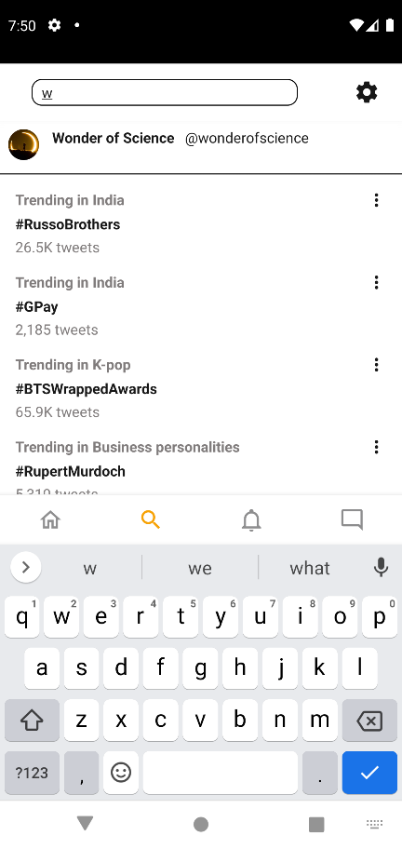

Tab 3: Notifications Tab

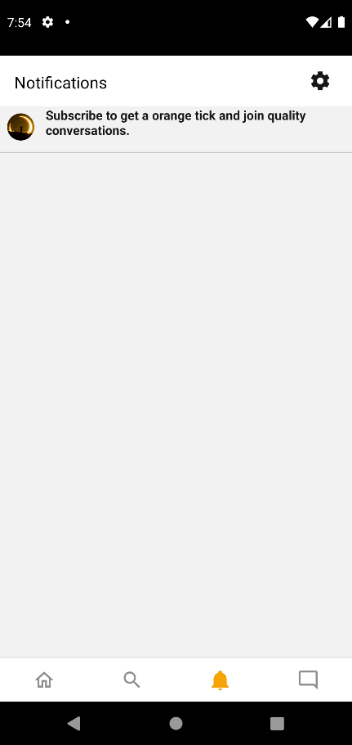

Tab 4: Messages Tab

react-native-gifted-chat package.

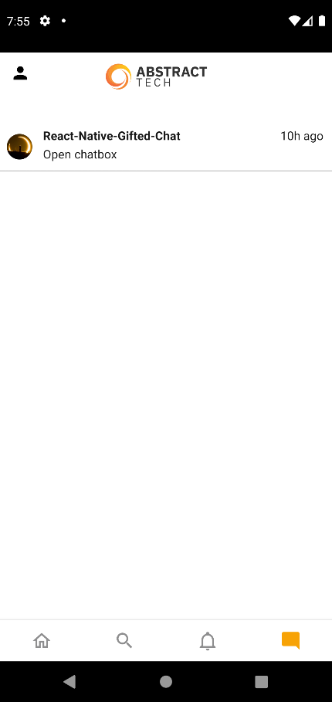

Chatbox.

